**Ex. No:11C Date:22/10/2024**

**Roll No:231901002**

**REMOTE PROCEDURE CALL FOR LIST OPERATIONS- XMLRPC**

**Aim:**

To Implement an XML RPC code for the following functions, a. No of items in a

list

**Algorithm:**

**Server side:**

1. Import `SimpleXMLRPCServer`.
2. Define list functions (`length`, `maximum`, `minimum`, `to_set`, ` concatenate`).
3. Create server on `localhost` with port `8000`.
4. Print "Listening on port 8000...".
5. Register functions with the server.
6. Start the server with `serve_forever()`.
7. Server listens and responds to client requests.

**Client side:**

1. Import `xmlrpc.client` to interact with the XML-RPC server.
2. Create a `ServerProxy` object to connect to the XML-RPC server at `http://localhost:8000/`.
3. Enter a loop to repeatedly prompt the user for input to start or stop operations.
4. If the user chooses to start (option 1), prompt the user to input elements for two separate lists (`a` and `b`), stopping when `-1` or `-2` is entered.
5. If the user chooses to stop (option 2), exit the loop.
6. Once the lists are gathered, print the contents of both lists (`a` and

`b`).

1. Call the registered XML-RPC functions (`list_length`,

`list_maximum`, `list_minimum`, `list_to_set`, `list_concate`) via the server proxy and print the results.

**Program**

**Server Side:**

from xmlrpc.server import SimpleXMLRPCServer def list_length(a):

return len(a) def list_maximum(a): return max(a) def list_minimum(a): return min(a) def list_to_set(a):

f=list(set(a)) return f def list_concate(a,b):

return a+b

server = SimpleXMLRPCServer(("localhost", 8000)) print("Listening on port 8000...")

server.register_function(list_length,"list_length") server.register_function(list_maximum, "list_maximum") server.register_function(list_minimum, "list_minimum") server.register_function(list_to_set, "list_to_set") server.register_function(list_concate, "list_concate") server.serve_forever()

**Client Side:**

import xmlrpc.client proxy= xmlrpc.client.ServerProxy('http://localhost:8000/') while True:

print("PRESS 1-->STRAT || 2--> STOP ") c=int(input("ENTER YOUR CHOICE")) a=[] b=[] if c==1:

print("ENTER THE ELEMENTS TO ADD FIRST LIST") print("PRESS -1 TO EXIT THIS LIST") while True:

d=int(input("--->")) if d==-1: break

a.append(d)

print("ENTER THE ELEMENTS TO ADD SECOND LIST") print("PRESS -2 TO EXIT THIS LIST") while True:

e=int(input("--->")) if e==-2: break

b.append(e) if c==2: break print(a) print(b)

print("list_length",proxy.list_length(a)) print("list_maximum",proxy.list_maximum(a)) print("list_minimum",proxy.list_minimum(a)) print("list_to_set",proxy.list_to_set(a)) print("list_concate",proxy.list_concate(a,b)) **Output:**

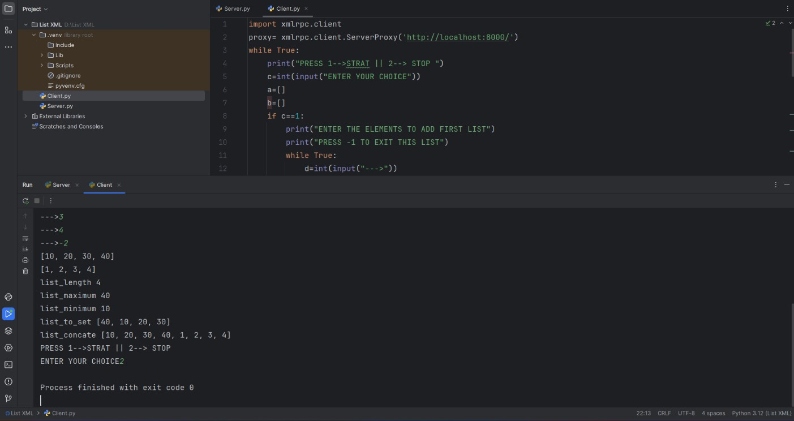

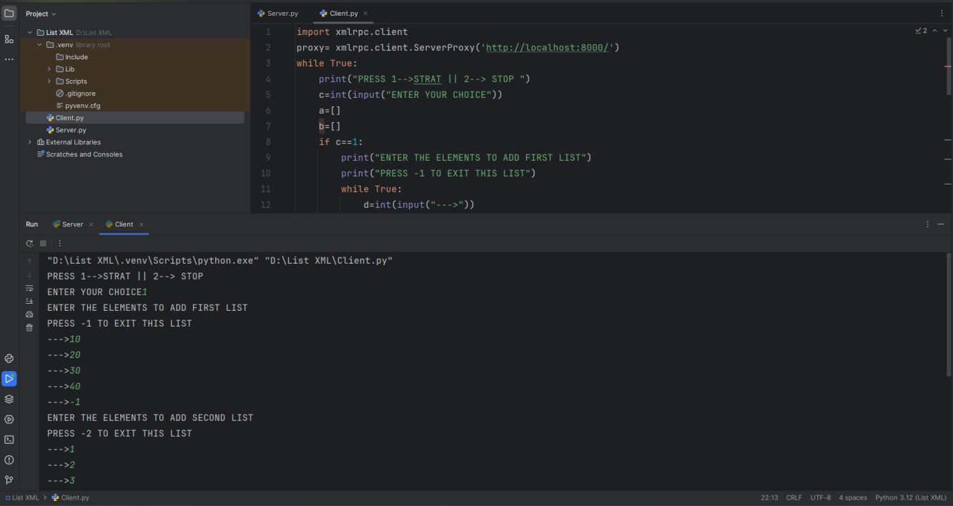

**Result:**

Thus, the list operations using Remote Procedure Call was executed.

